**Linear Regression**

* **Overall Significant Test**

Ho : Overall model is not significant

Ha : Overall model is significant

Response Variable: Survival Time

**Conclusion Significant test**

The p-value is small which suppots Ha. Therefore, the overall fitted Model is significant at α = 1%

Treatment is not significant while all the other explanatory variable are significant at α = 1%

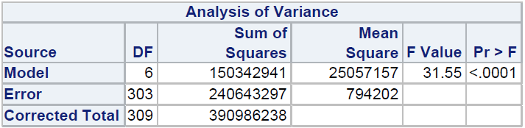

* **Variable selection method used**

Stepwise

**Final model**



Ŷ = -180.34407 – 35.12471 * (Treatment) -66.88416 * (Bilrubin) + 714.95866 *(Albumin) – 2.39953 *(Urine copper) + 0.12762 *(Alkaline phosphate) – 314.99749 *(Histologicstage4)

Treatment = { 1 = D-penicillamine

0 = placebo }

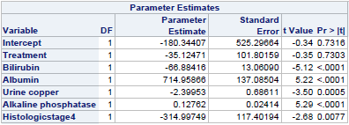

* **Checking model assumptions**

Normal Probability Plot of Residuals: Normal with few outliers

Ho : Residuals are normally distributed

Ha : Residuals are not normally distributed

|  |  |
| --- | --- |
| Test | Pvalue |
| Shapiro | 0.0356 |
| Kolmogorov Smirnov | 0.0377 |
| Cramer von | 0.0211 |
| Anderson Darling | 0.103 |

This At α = 1%. The Pvalue are large. Pvalue > α. We accept Ho (Residuals are not normally distributed)

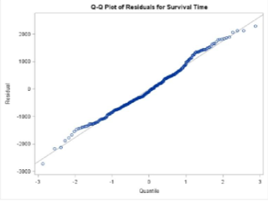

* **Checking for constancy of variance**

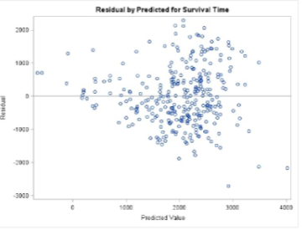

By looking at graph. We conclude constancy of variance is obtained. It is not violated